

REPUBLIC OF THE PHILIPPINES

DEPARTMENT OF THE PHILIPPINES

CARAGA ADMINISTRATIVE REGION

DIVISION OF AGUSAN DEL SUR

**SALVACION NATIONAL HIGH SCHOOL**

SALVACION, TRENTO, AGUSAN DEL SUR

**Narrative Report**

A

on

**6th Senior High School Graduation Ceremony**

“No goal was ever too hard to accomplish, failure was not an option, so keep your mindset on the bigger picture. Hard work, dedication, and wise-decision making will help you accomplish your graduation goal.” Teachers of Salvacion National High School always told these words to their learners. As the graduates stepped the stage to receive their diplomas, their hearts were filled with mixed emotions-love, sadness, and the self-fulfillment that they were once their teachers. Two years of providing quality education despite of COVID 19 pandemic had tremendous effect on students learning ability, SNHS was continuously soaring to a greater height. As the school celebrated this year’s 6th Senior High School Graduation Ceremony, it is determined in producing competitive and quality graduates, and it finally ended school year 2022-2023, with its graduation ceremony last July 13, 2023, at exactly 8:00 in the morning at school’s covered court with a theme, “***K to 12 Graduates: Molded Through a Resilient Educational Foundation***”.

The program started with the processional march of the candidates for graduation, parents, faculty, DepEd officials and guests. The graduating class led the singing of national anthem and invocation. Catherine Jean C. Sano, with honors, delivered confidently her welcome address to the dignitaries, his batchmates, parents, audience, faculty and staff. Olever B. Dicang, School Head, presented the candidates for graduation. It was attested by Dindo A. Correos, Public Schools District In-charge of Trento III, and the confirmation led by Lelani R. Abutay, SDO Education Program Supervisor as the representative of Josita B. Carmen, CESO V, Schools Division Superintendent. The newly confirmed senior high school graduates couldn’t picture the happiness they felt with their proud parents or guardian as they received their diplomas and awards. Ma’am Abutay shared her heart-warming and thought- provoking to the graduates. Jasper Lynne C. Villanueva, Senior High School Teacher I, was given the task to introduce the guest speaker, Shedy Rey C. Ayucan-alumnus. The tail of success of the guest speaker made the graduates inspired to keep holding even there lots of trials and challenges along the way.

The ambiance of the ceremony became emotional as Allieza O. Coloma, with high honors, delivered her speech of gratitude with overflowing joy and tears of gratefulness. It was followed by pledge of loyalty led by Mark Angelo E. Marquez, with honors. Some of the graduates could no longer again held their tears they sang their tribute song to their dear parents as expression of their love and boundless appreciation. The 6th graduation ceremony concluded around 9:50 O’clock in the morning.

Prepared by: Noted:

**RENDON G. CHUCAS OLEVER B. DICANG**

*English Teacher School Head*

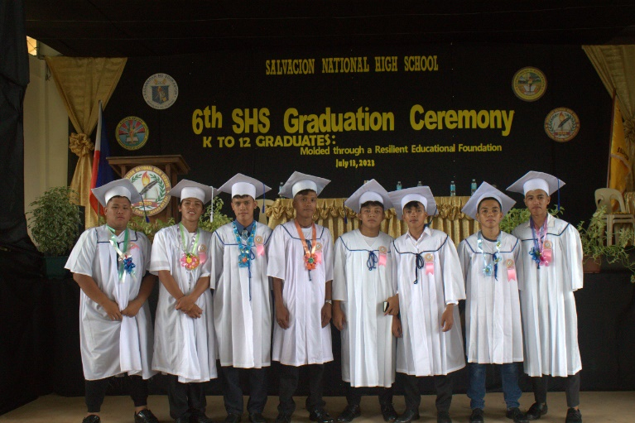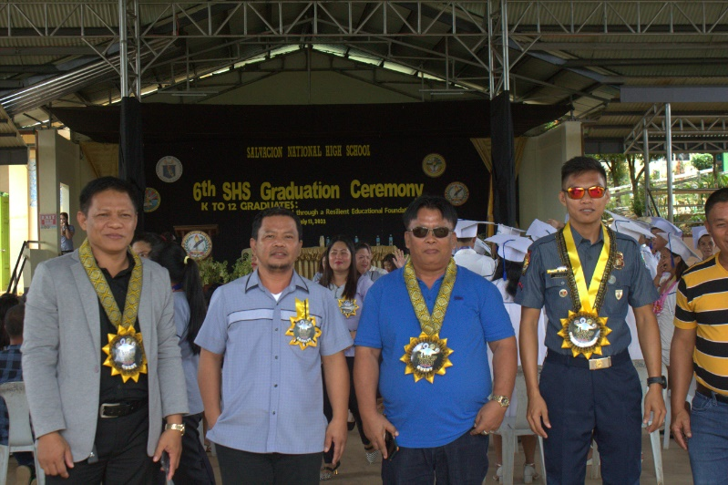

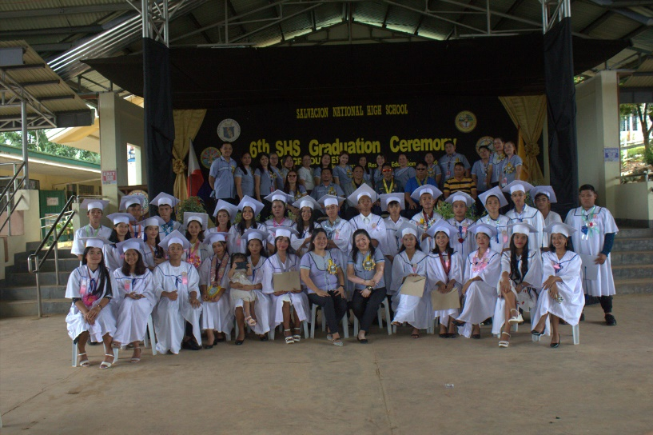

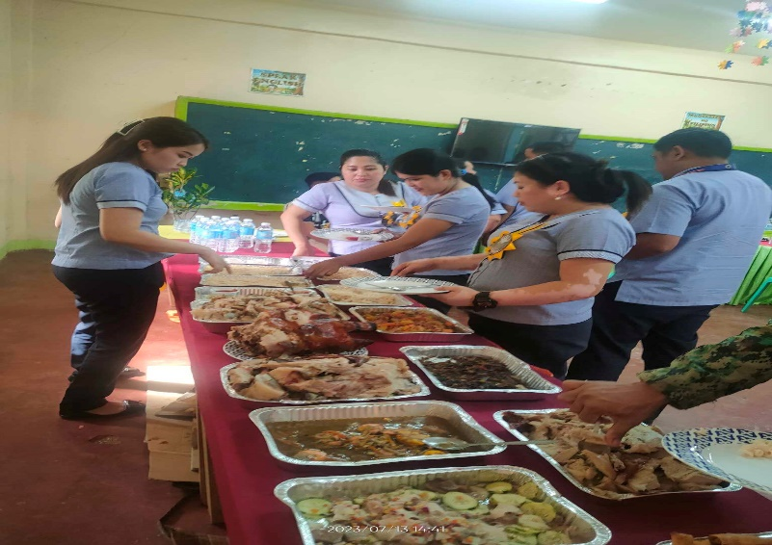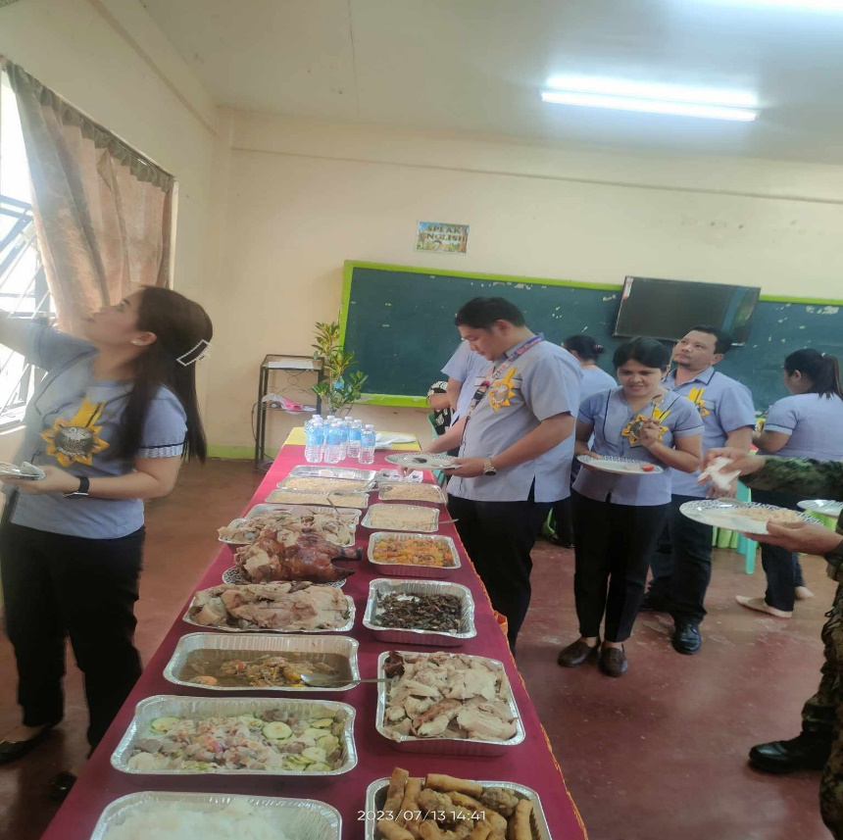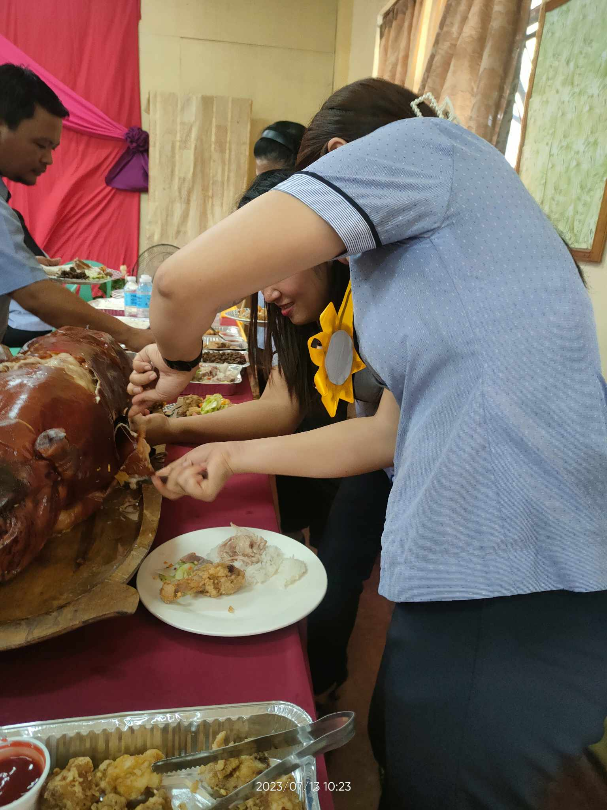

PICTORIALS